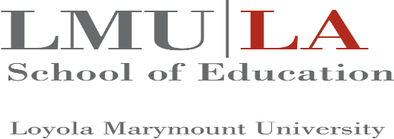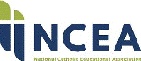

Certificate of Attendance
presented to

___________________________________________________________

Education Law Symposium
July 10-13, 2025
14 clock hours

Loyola Marymount University
National Catholic Educational Association

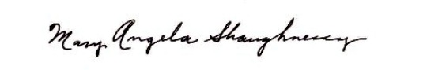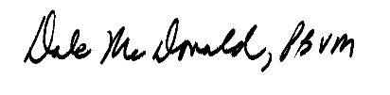
Mary Angela Shaughnessy, SCN Dale McDonald, PBVM
Director Co-Director

